1. Use HTML text formatting tags to create web page as per given sample.

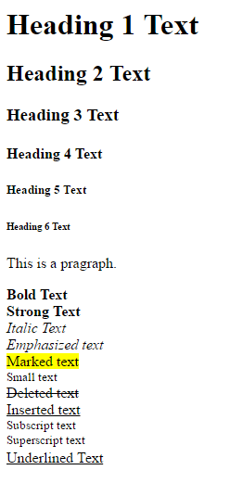

**HTML Code:-**

<!DOCTYPEhtml>

<html>

<body>

<h1>Heading 1 Text</h1>

<h2>Heading 2 Text</h2>

<h3>Heading 3 Text</h3>

<h4>Heading 4 Text</h4>

<h5>Heading 5 Text</h>

<h6>Heading 6 Text</h6>

<p>This is a Paragraph.</p>

<pre><b>Bold Text</b>

<strong>Strong Text</strong>

<i>Italic Text</i>

<em>Emphasized Text</em>

<mark>Marked Text</mark>

<small>Small Text</small>

<del>Deleted Text</del>

<ins>Inserted Text</ins>

<sub>Subscript Text</sub>

<sup>Superscript Text</sup>

<u>Underlined Text</u></pre>

</body>

</html>

**Output:-**

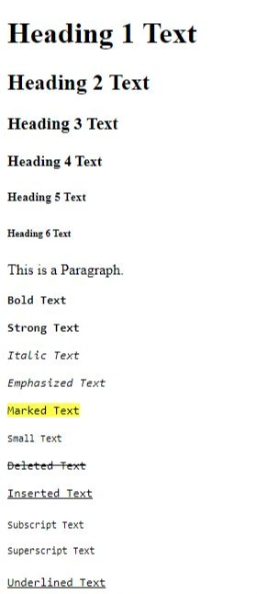

1. Use hyper link tag to navigate through different web pages as per given sample.

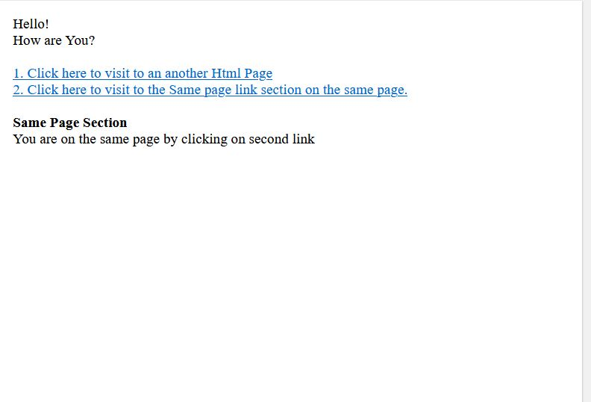

**HTML Code:-**

<!DOCTYPE html>

<html>

<body>

<p>Hello! </p>

<p>How are You? </p>

<pre>

<a href = "C:\Users\sai\Documents\Practical 1.html">1. Click here to visit another HTML page.</a>

<a href="#Same page">2. click here to visit to the same page section on the same page. </a>

<pre>

<p id= "Same Page"><b>Same page Section.</b></p>

<p>You are on the same page by clicking on the second link </p>

</body>

</html>

**OUTPUT:-**

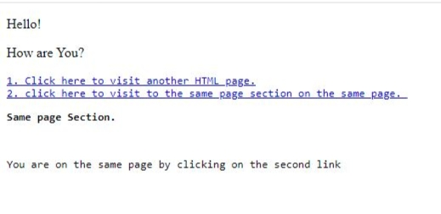

1. Use image tags to create web page as per given sample. (Take any 1 image from your computer to display)



**HTML Code :-**

<!doctypehtml>

<html>

<body>

<img src= "C:\Users\sai\Documents\IMG20210829163111.jpg"alt="statue of Gandhiji in Forest." style"float:left;">

<img src= "C:\Users\sai\Documents\IMG20211109142355.jpg"alt="a villege's image." >

<img src= "C:\Users\sai\Documents\IMG20211112145716.jpg"alt="A big Temple" style"float:right;">

</body>

</html>

**OUTPUT:-**

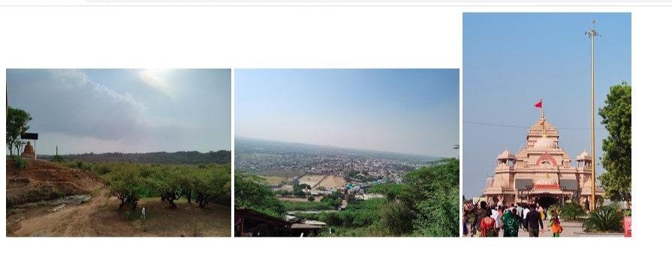

1. Use HTML table tags to create web page as per given sample.

(Put following code under <head> tag to create border.)

<style>

table, th, td {

border: 1px solid black;

}

</style>

Or

<table border=”1”>

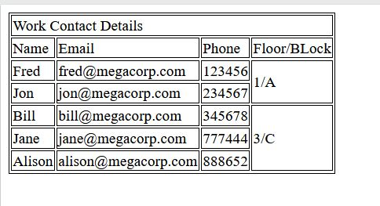

**HTML Code:-**

<!doctypehtml>

<html>

<head>

<style>

table , th , td{

border : 1px solid black;

}

</style>

</head>

<body>

<table>

<tr>

<td colspan="6">Work Contact Details</td>

</tr>

<tr>

<td>Name</td>

<td colspan="2">Email</td>

<td>phone</td>

<td colspan="2">Floor/Block</td>

</tr>

<tr>

<td>Fred</td>

<td colspan="2">fred@megacorp.com</td>

<td>123456</td>

<td colspan="2" rowspan="2">1/A</td>

</tr>

<tr>

<td>Jon</td>

<td colspan="2">jon@megacorp.com</td>

<td>234567</td>

</tr>

<tr>

<td>Bill</td>

<td colspan="2">bill@megacorp.com</td>

<td>345678</td>

<td colspan="2" rowspan="3">3/C</td>

</tr>

<tr>

<td>Jane</td>

<td colspan="2">jane@megacorp.com</td>

<td>777444</td>

</tr>

<tr>

<td>Alison</td>

<td colspan="2">alison@megacorp.com</td>

<td>888652</td>

</tr>

</table>

</body>

</html>

**OUTPUT:-**

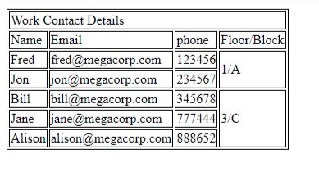

1. Use sorted list to create web page as per given sample page.

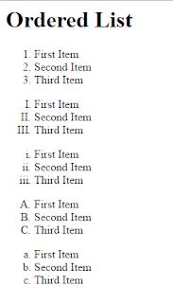

**HTML Code:-**

<!doctypehtml>

<html>

<body>

<h1> Ordered List</h1>

<ol type="1">

<li>First Item</li>

<li>Second Item</li>

<li>Third Item</li>

</ol>

<ol type="A">

<li>First Item</li>

<li>Second Item</li>

<li>Third Item</li>

</ol>

<ol type="a">

<li>First Item</li>

<li>Second Item</li>

<li>Third Item</li>

</ol>

<ol type="I">

<li>First Item</li>

<li>Second Item</li>

<li>Third Item</li>

</ol>

<ol type="i">

<li>First Item</li>

<li>Second Item</li>

<li>Third Item</li>

</ol>

</body>

</html>

**OUTPUT:-**

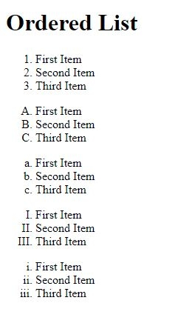

1. Use unsorted list to create web page as per given sample page.

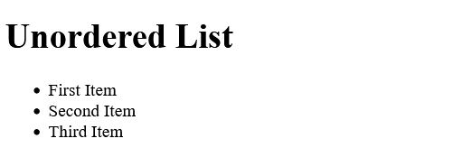

**HTML Code:-**

<!doctypehtml>

<html>

<body>

<h1> Unorderd List</h1>

<ul type="disc">

<li>First Item</li>

<li>Second Item</li>

<li>Third Item</li>

</ul>

</body>

</html>

**OUTPUT:-**

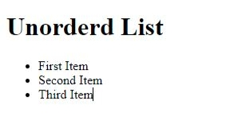

1. 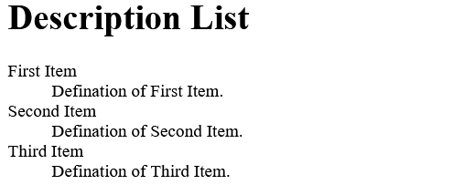Use definition list to create web page as per given sample page.

**HTML Code:-**

<!doctypehtml>

<html>

<body>

<h1>Description List</h1>

<dl>

<dt>First Item</dt>

<dd>Defination of First Item.</dd>

<dt>Second Item</dt>

<dd>Defination of Second Item.</dd>

<dt>Third Item</dt>

<dd>Defination of Third Item.</dd>

</dl>

</body>

</html>

**OUTPUT:-**

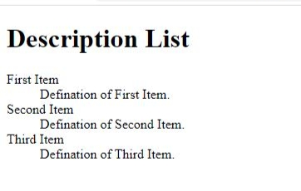

1. Use semantic tags to organize web page contents as per given sample.

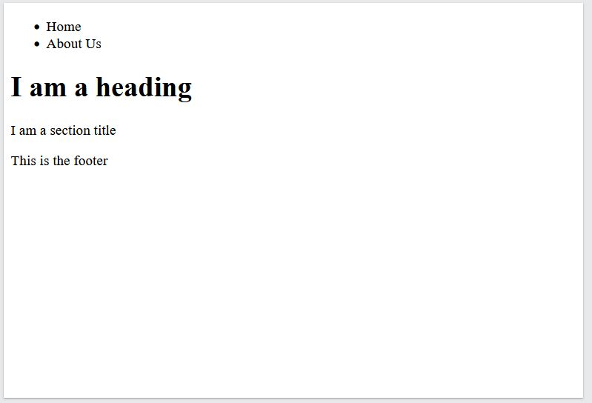

**HTML Code:-**

<!DOCTYPE html>

<html>

<body>

<header>

<ul>

<li> Home</li>

<li> About Us</li>

<ul>

</header>

<article>

<h1>I am a Heading.</h1>

</article>

<section>

<p>I am a Section Title.</p>

</section>

<footer>

<p>Tis is the Footer.</p>

</footer>

</body>

</html>

**OUTPUT:-**

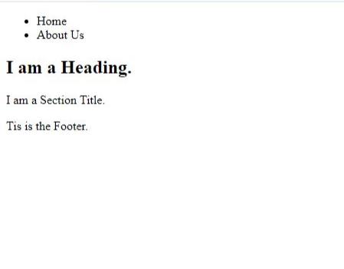

1. a. Create a student registration webpage using different HTML form elements.

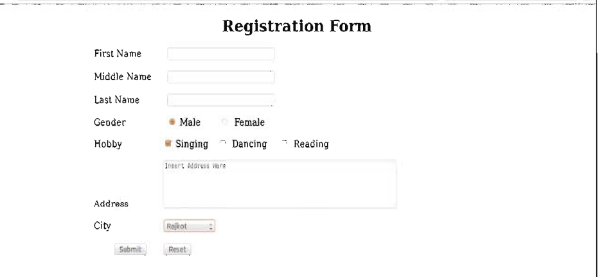

**HTML Code:-**

<!DOCTYPE html>

<html>

<body>

<h1>Registration Form</h1>

<form>

<lable for="Firstname"><b>First name :-</b></lable>

<input type="text" id="First name" name="First name"><br><br>

<lable for="Middle name"><b>Middle name :-</b></lable>

<input type="text" id="Middle name" name="Middle name"><br><br>

<lable for="Lastname"><b>Last name :-</b></lable>

<input type="text" id="larst name" name="last name"><br><br>

<lable for="Gender"><b>Gender :-</b></lable>

<input type="radio" id="Gender" name="Gender" >

<lable for="Gender"><b>Male</b></lable>

<input type="radio" id="Gender" name="Gender" >

<lable for="Gender"><b>Female</b></lable><br><br>

<lable for="Hobby"><b>Hobby:-</b></lable>

<input type="checkbox" id="Hobby" name="Hobby" >

<lable for="Hobby"><b>Singing</b></lable>

<input type="checkbox" id="Hobby" name="Hobby" >

<lable for="Hobby"><b>Dancing</b></lable>

<input type="checkbox" id="Hobby" name="Hobby" >

<lable for="Hobby"><b>Reading</b></lable><br><br>

<lable for="Address"><b>Address:-</b></lable>

<textarea name="Address" rows="5" cols="50">Insert Address Here</textarea><br><br>

<lable for="City"><b>City:-</b></lable>

<select id="city" name="city">

<option value="Ahmedabad">Ahmedabad</option>

<option value="Surat">Surat</option>

<option value="Gandhinagar">Gandhinagar</option>

<option value="Rajkot">Rajkot</option>

<option value="Jamnagar">Jamnagar</option>

<option value="Vadodara">Vadodara</option>

</select><br><br>

<input type="submit" value="submit">

<input type="reset">

</form>

</body>

</html>

**OUTPUT:-**

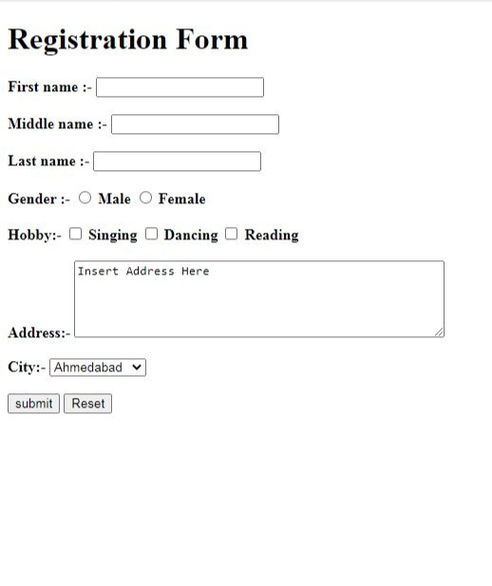

b. Create student feedback form using different HTML form elements.

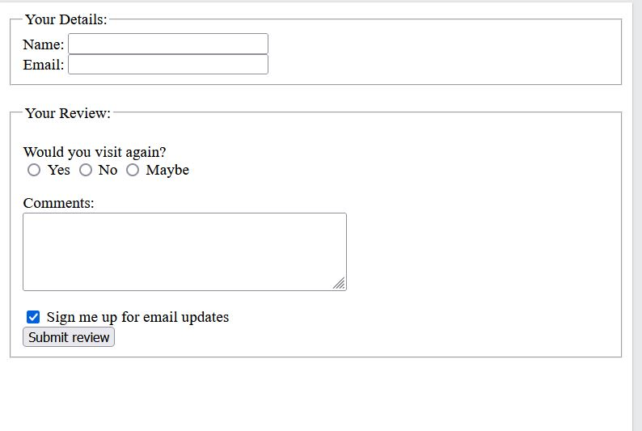

**HTML Code:-**

<!doctype html>

<html>

<head>

<style>

fieldset {

width:750px;

}

textarea{

width:500px;

height:100px;

}

</style>

</head>

<body>

<fieldset>

<legend> Your details:- </legend>

<lable for="Name">Name:- </lable>

<input type="text" id="Name" name="Name"><br><br>

<lable for="Email"> Email:- </lable>

<input type="text" id="Email" Name="Email">

</fieldset><br><br>

<fieldset>

<legend> Your Review:- </legend>

<lable for="your review">Would You Visit Again ?</lable><br>

<input type="radio" id="review 1" Name="Review 1">

<lable for="review 1"> yes</lable>

<input type="radio" id="review 2" Name="Review 2">

<lable for="review 2"> No</lable>

<input type="radio" id="review 3" Name="Review 3">

<lable for="review 3"> May be</lable><br><br>

<lable for="your feedback"> Comments:-</lable><br>

<textarea name="Your Feedback"> Enter Your Comments Here.</textarea><br><br><br><br>

<input type="checkbox" id="sign up" Name="Sign up">

<lable for="Sign up"> Sign me up for Email Update.</lable><br><br>

<input type="submit" value="Submit review">

</fieldset>

</body>

</html>

**OUTPUT:-**

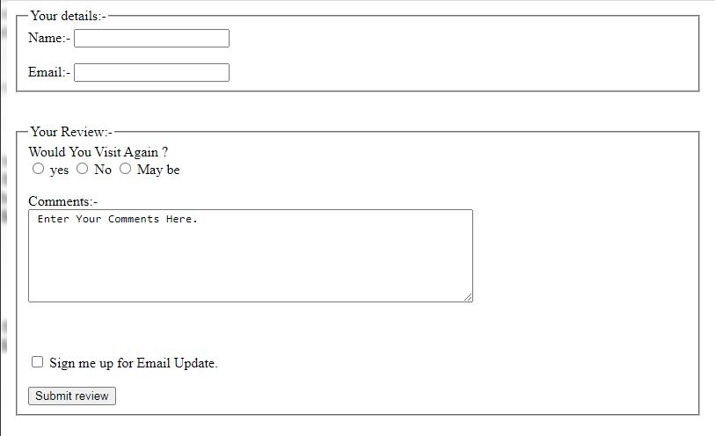

1. Create bank account opening form using different HTML form elements in Kompozer.

**HTMLcode:-**

<html>  
<head>  
<meta id="_moz_html_fragment">  
</head>  
<body>  
<form method="post" action="#" name="Practical 10">  
<h1 style="text-align: center;"><span  
style="text-decoration: underline;">Bank Account Opening Form</span></h1>  
<big>&nbsp;&nbsp;&nbsp; Account Type :- </big><br>  
<big>&nbsp;&nbsp;&nbsp;  
<select name="Account Type">  
<option>Current Account</option>  
<option>Saving Account</option>  
<option>Personal Account</option>  
</select>  
</big><br>  
<ol>  
<li>&nbsp;<big>Name :-</big> <input name="Name" value="First Name"  
style="border-style: solid; border-width: 2px; margin-left: 134px;"><big>  
</big><input name="Name" value="Last Name"  
style="border-style: solid; border-width: 2px;"></li>  
<li><big>Father/Gaurdian's name :- </big><input  
name="Father/ Guardian's Name"  
style="border-style: solid; border-width: 2px;"></li>  
<li><big>Phone :- </big><input name="Phone "  
style="border-style: solid; border-width: 2px; margin-left: 135px;"></li>  
<li><big>Monthly Salary :-&nbsp;</big>  
<select name="Monthly Salary" style="margin-left: 63px;">  
<option>below 10,000</option>  
<option>10,000 to 20,000</option>  
<option>20,000 to 30,000</option>  
<option>30,000 to 50,000</option>  
<option>above 50,000</option>  
</select>  
</li>  
<li><big>Address:-</big><br>  
<textarea cols="50" rows="2" name="Address"  
style="border-style: solid; border-width: 2px;">Permanent  
Address</textarea><br>  
<textarea cols="50" rows="2" name="Address"  
style="border-style: solid; border-width: 2px;">Address Line 2</textarea></li>  
<li><big>City :- </big><input name="City"  
style="border-style: solid; border-width: 2px; margin-left: 147px;"></li>  
<li><big>Region :- </big><input name="Region"  
style="border-style: solid; border-width: 2px; margin-left: 125px;"></li>  
<li><big>Postal Code :- </big><input name="Postal Code"  
style="border-style: solid; border-width: 2px; margin-left: 88px;"></li>  
<li><big>Identity Proof :-&nbsp; </big>  
<select name="Identity Proof" style="margin-left: 69px;">  
<option>Adhar Card</option>  
<option>Pan Card</option>  
<option>Driving Licence</option>  
<option>Passport</option>  
<option>Election Card</option>  
</select>  
</li>  
<li><big>Identity Number :- </big><input name="Identity Number"  
style="border-style: solid; border-width: 2px; margin-left: 53px;"></li>  
<li><big>Signature Of Applicant :- </big><input name="Signature"  
style="border-style: solid; border-width: 2px; margin-left: 3px;"></li>  
</ol>  
<br>  
&nbsp;&nbsp;&nbsp; <input name="Submit" value="Submit" type="submit"></form>  
</body>  
</html>

**OUTPUT:-**

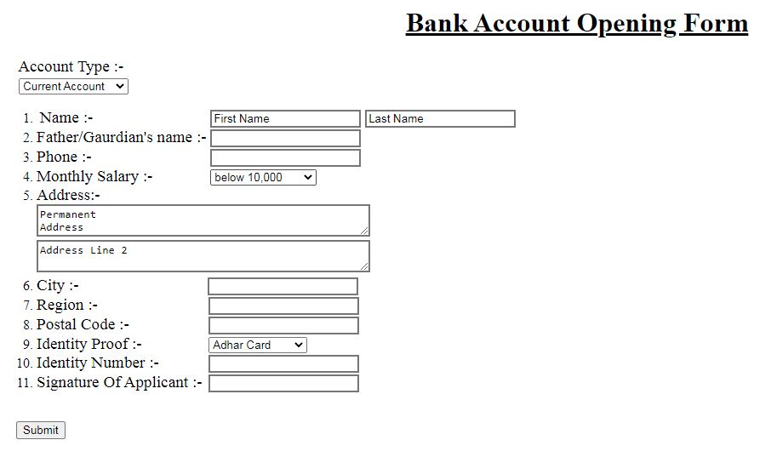

1. Use inline , internal and external style sheets for student registration form and bank acoount opening form created in previous practicals.

**HTML code :-**

<!DOCTYPE html>

<html>

<head>

<link rel="stylesheet" href="Studentregistrationform.css">

<style>

#head {

text-decoration: underline;

text-align: centre;

color: black;

outline: solid;

background-color: lightgray;

}

</style>

</head>

<body>

<h1 id="head">Registration Form</h1>

<form>

<lable for="Firstname" class="forname"><b>First name :-</b></lable>

<input type="text" id="Firstname" name="First name" class="name" placeholder="your name..."><br><br>

<lable for="Middle name" class="forname""><b>Middle name :-</b></lable>

<input type="text" id="Middlename" name="Middle name" class="name" placeholder="your middle name..."><br><br>

<lable for="Lastname" class="forname""><b>Last name :-</b></lable>

<input type="text" id="lastname" name="last name" class="name" placeholder="your last name..."><br><br>

<lable for="Gender" class="gender"><b>Gender :-</b></lable>

<input type="radio" id="Gender" name="Gender">

<lable for="Gender" class="gender"><b>Male</b></lable>

<input type="radio" id="Gender" name="Gender">

<lable for="Gender" class="gender"><b>Female</b></lable><br><br>

<lable for="Hobby" class="hobby"><b>Hobby:-</b></lable>

<input type="checkbox" id="Hobby" name="Hobby" >

<lable for="Hobby" class="hobby"><b>Singing</b></lable>

<input type="checkbox" id="Hobby" name="Hobby" >

<lable for="Hobby" class="hobby"><b>Dancing</b></lable>

<input type="checkbox" id="Hobby" name="Hobby" >

<lable for="Hobby" class="hobby"><b>Reading</b></lable><br><br>

<lable for="Address" id="address"><b>Address:-</b></lable>

<textarea name="Address" rows="5" cols="50" placeholder="insert address here..."></textarea><br><br>

<lable for="City" id="city"><b>City:-</b></lable>

<select id="cityname" name="city">

<option value="Ahmedabad">Ahmedabad</option>

<option value="Surat">Surat</option>

<option value="Gandhinagar">Gandhinagar</option>

<option value="Rajkot">Rajkot</option>

<option value="Jamnagar">Jamnagar</option>

<option value="Vadodara">Vadodara</option>

</select><br><br>

<input type="reset">

<input type="submit" value="submit">

</form>

</body>

</html>

**CSS code:-**

* {

text-align: center;

}

input[type=text] {

border: 2px solid black;

border-radius: 5px;

outline-style: double;

}

lable.forname {

color: black;

}

.gender {

color: black;

}

.hobby {

color: black;

}

#address {

color: black;

}

#city {

color: black;

}

#cityname {

color: black;

}

textarea {

background-color: rgb(200,200,200);

border: 2px solid black;

border-radius: 2px;

}

select {

background-color: gray;

border: 2px solid black;

border-radius: 2px;

}

input[type=reset] {

border: 2px solid black;

text-decoration: underline;

height: 25px;

width: 90px;

color: white;

background-color: green;

}

input[type=submit] {

border: 2px solid black;

text-decoration: underline;

height: 25px;

width: 90px;

color: white;

background-color: green;

}

**OUTPUT:-**

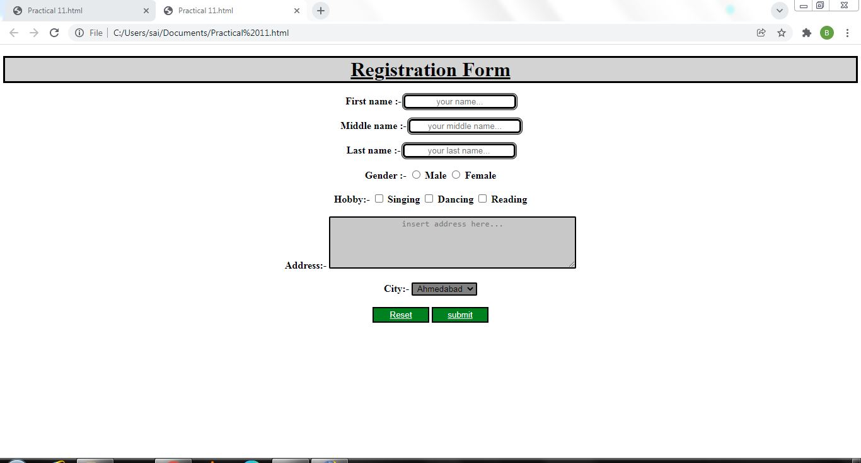

1. a. Use different CSS elements to create and and format your Profile Page.

**HTML code:-**

<!DOCTYPEhtml>

<html>

<head>

<link rel="stylesheet" href="Practical12.css">

</head>

<body>

<div class="container">

<div class="main">

<div class="topbar">

<a href="">logout</a>

<a href="">Support</a>

<a href="">work</a>

<a href="">home</a>

</div>

<br>

<div class="row">

<div class="col-md-8 mt-1">

<div class="card mb-3 content">

<h1 class="m-3 pt-3">About</h1>

<div class="card-body">

<div class="row">

<div class="col-md-3">

<h5>Full name</h5>

</div>

<div class="col-md-9 text-secondary">

Ronak Javiya

</div>

</div>

<hr>

<div class="row">

<div class="col-md-3">

<h5>E-mail</h5>

</div>

<div class="col-md-9 text-secondary">

ronakjaviya26@gmail.com

</div>

</div>

<hr>

<div class="row">

<div class="col-md-3">

<h5>Phone</h5>

</div>

<div class="col-md-9 text-secondary">

7862838889

</div>

</div>

<hr>

<div class="row">

<div class="col-md-3">

<h5>Address</h5>

</div>

<div class="col-md-9 text-secondary">

34, suradhinagar, Chndlodia, Ahmedabad.

</div>

</div>

</div>

</div>

</div>

</div>

</div>

</div>

</body>

</html>

**CSS code:-**

body {

margin-top: 20px;

background-color: lightgray;

}

.main{

padding: 15px;

font-family: Arial, Helvetica, sans-serif;

}

.topbar{

background-color: teal;

overflow: hidden;

}

.topbar a{

float: right;

color: whitesmoke;

text-align: center;

padding: 20px 26px;

text-decoration: none;

font-size: 26px;

}

.sidebar {

background-color: #333;

color: white;

width: 40%;

height: 100%;

}

.sidebar a {

text-align: center;

margin-left: 10px;

display: block;

color: white;

padding: 10px;

font-size: 30px;

text-decoration: none;

}

.content {

background-color: whitesmoke;

position: absolute;

right: 24px;

bottom: 135px;

width: 60%;

}

**OUTPUT:-**

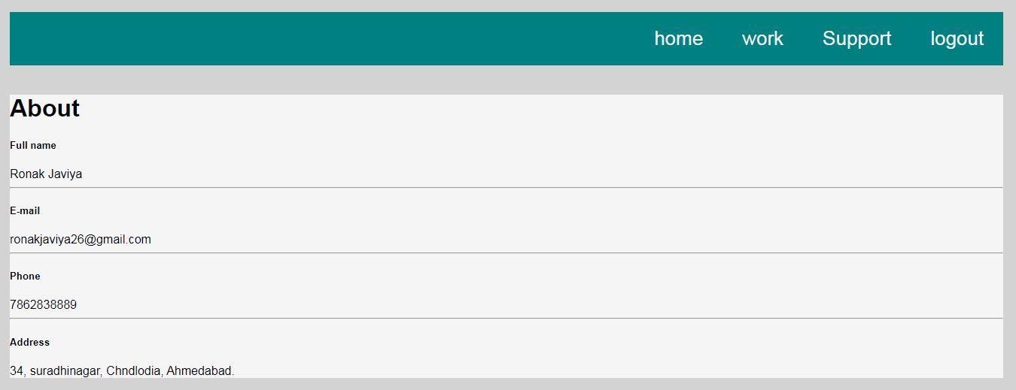

b. Create and format your class time table page using different CSS elements.

**HTML code:-**

<!DOCTYPEhtml>

<html>

<head>

<link rel="stylesheet" href="Practical12b.css">

</head>

<body>

<h1>Time Table :- 1st Sem</h1>

<div>

<table>

<tr>

<th>Sr no. </th>

<th>time </th>

<th>Monday </th>

<th>Tuesday </th>

<th>Wednesday </th>

<th>Thursday </th>

<th>Friday </th>

<th>Saturday </th>

</tr>

<tr>

<td class="First">1 </td>

<td class="Second">10.30 to 11.30 </td>

<td Class="Third">English<br>AMJ </td>

<td Class="Forth"> </td>

<td Class="Fifth"> </td>

<td Class="Sixth"> </td>

<td Class="Seventh"> </td>

<td Class="Eighth" rowspan="2">Sports & Yoga<br>RGC </td>

</tr>

<tr>

<td class="First">2 </td>

<td class="Second">11.30 to 12.30 </td>

<td Class="Third">PP<br>MVP </td>

<td Class="Forth">Maths<br>MCS </td>

<td Class="Fifth">English<br>AMJ </td>

<td Class="Sixth">Maths<br>MCS </td>

<td Class="Seventh">IIS<br>MAM </td>

</tr>

<tr>

<td class="First">3 </td>

<td class="Second">12.30 to 01.30 </td>

<td Class="Third">Maths<br>MCS </td>

<td Class="Forth">IIS(br)MAM </td>

<td Class="Fifth">IIS<br>MAM </td>

<td Class="Sixth" rowspan="2">A1-IIS(SPG)<br>A2-PP(V6)<br>A3-SWD(V5) </td>

<td Class="Seventh" rowspan="2">A1-SWD(V1)<br>A2-IIS(RGC)<br>A3-PP(V2) </td>

<td Class="Eighth"> </td>

</tr>

<tr>

<td class="First">4 </td>

<td class="Second">02.00 to 03.00 </td>

<td Class="Third" rowspan="2">A1-SWD(SMV)<br>A2-PP(V1)<br>A3-IIS(V2) </td>

<td Class="Forth" rowspan="2">LAB<br>English<br>AMJ </td>

<td Class="Fifth" rowspan="2">Sports & Yoga<br>RGC </td>

<td Class="Sixth"> </td>

</tr>

<tr>

<td class="First">5 </td>

<td class="Second">03.00 to 04.00 </td>

<td Class="Sixth">Tut Maths<br>MCS </td>

<td Class="Third">PP<br>SPG </td>

<td Class="Eighth" rowspan="2">A1-PP(PBT)<br>A2-SWD(V1)<br>A3-PP(V2) </td>

</tr>

<tr>

<td class="First">6 </td>

<td class="Second">04.10 to 05.10 </td>

<td Class="Third" rowspan="2">A1-IIS(MAM)<br>A2-IIS(V4)<br>A3-SWD(V3) </td>

<td Class="Forth" rowspan="2">A1-PP(PBT)<br>A2-SWD(SMV)<br>A3-IIS(V5) </td>

<td Class="Fifth">PP<br>PBT </td>

<td Class="Sixth"> </td>

<td Class="Seventh"> </td>

</tr>

<tr>

<td class="First">7 </td>

<td class="Second">05.10 to 06.10 </td>

<td Class="Third"> </td>

<td Class="Forth"> </td>

<td Class="Fifth"> </td>

<td Class="Sixth"> </td>

</tr>

</div>

</body>

</html>

**CSS code:-**

h1 {

text-align: center;

text-decoration: underline;

border: 2px solid black;

background-color: #ffece0;

}

div {

position: absolute;

right: 20%;

text-align: center;

}

table,tr,th,td {

border: 5px solid #70778f;

border-collapse: collapse;

padding: 5px;

color: #282b2f ;

}

th {

background-color: #969a9c;

}

.First {

background-color: #b1b3b4;

}

.Third {

background-color: #b1b3b4;

}

.Fifth {

background-color: #b1b3b4;

}

.Seventh {

background-color: #b1b3b4;

}

.Second {

background-color: #d8d9da;

}

.Forth {

background-color: #d8d9da;

}

.Sixth {

background-color: #d8d9da;

}

.Eighth {

background-color: #d8d9da;

}

**OUTPUT:-**

